SEVEN AND EIGHT-COORDINATED DIMETHYL-N-BENZOYLAMIDOPHOSPHATE BASED DYSPROSIUM COMPLEXES: STRUCTURE, LUMINESCENCE AND MAGNETIC PROPERTIES

Struhatska M.B.¹, Kariaka N.S.¹, Dyakonenko V.V.², Shishkina S.V.², Porębski P.³, Gawryszewska P.³, Bienko A.³, Amirkhanov V.M.¹
¹ Taras Shevchenko National University of Kyiv, 01601, Kyiv, Volodymyrska str., 64/13; mariya.strugatskaya@gmail.com
² SSI ‘‘Institute for Single Crystals’’, National Academy of Sciences of Ukraine, 61001, Kharkiv, Nauky ave., 60; sveta@xray.isc.kharkov.com
³ University of Wroclaw, 14 F. Joliot-Curie Str., 50-383, Wroclaw, Poland; paula.gawryszewska-wilczynska@uwr.edu.pl

Dy(III) coordination compounds have attracted increasing interest due to their luminescent and magnetic properties. Dy (III) ion can emit blue light at about 480 nm and yellow light at about 572 nm. If the blue/yellow intensity ratio is tuned properly, a white light would be obtained. This makes Dy (III) complexes popular objects in the research field of organic light-emitting diodes [1]. The unquenched angular moment with a ⁶H_{15/2} ground state and an unparalleled uniaxial single-ion anisotropy of Dy (III) ion make its complexes promising for the development of single molecular magnets, which are considered to find applications in data storage, molecular spintronics, and quantum computing [2].
Herein we report the synthesis and investigations of dysprosium (III) coordination compounds [DyL₃TPPO] and [DyL₃phen] with carbacylamidophosphate type ligand dimethyl-N-benzoylamidophosphate (HL = [C₆H₅CONHPO(OCH₃)₂]) and additional ligands triphenylphosphine (TPPO) oxide and 1,10-phenantroline (phen). The obtained complexes were characterized by means of X-Ray analysis, IR and luminescence spectroscopy as well as their magnetic behavior was studied.
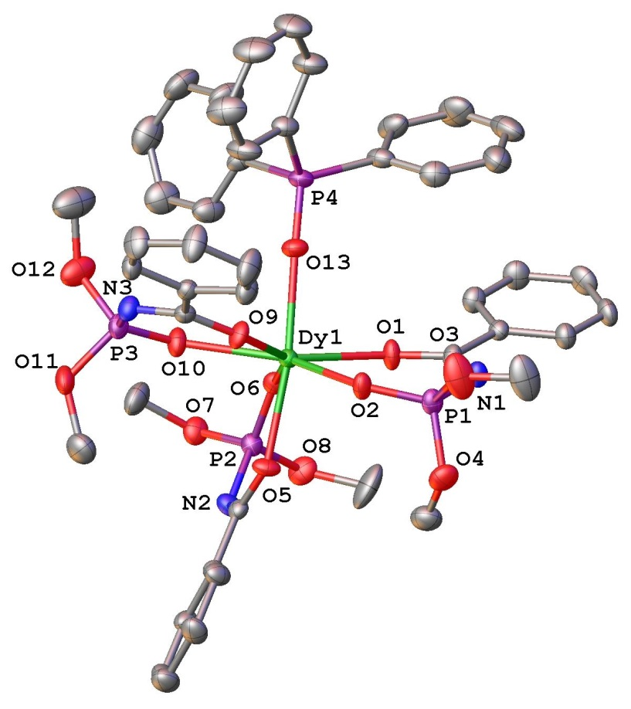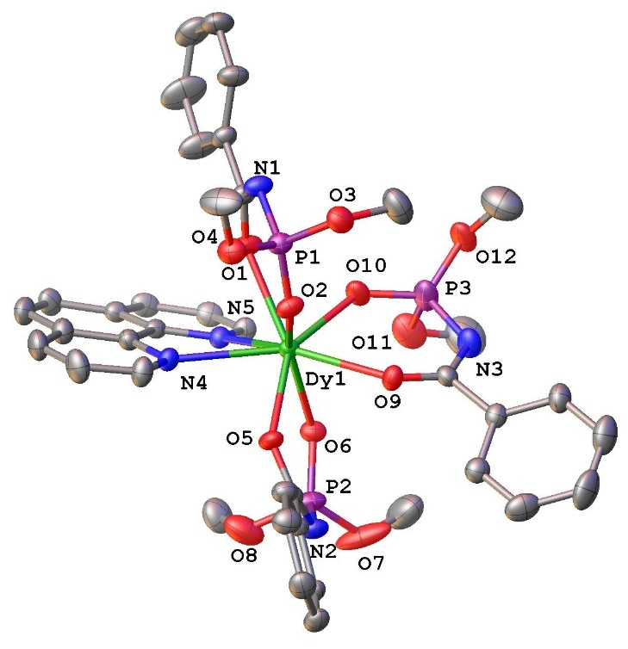
Figure 1. Molecular structure of [DyL₃TPPO] (left panel) and [DyL₃phen] (right panel)

The both complexes crystalize in triclinic crystal system, P-1 space group with one molecule in the asymmetric part of the unit cell. The dimethyl-N-benzoylamidophosphate is coordinated to the Dy(III) ion in deprotonated form in bidentate chelating manner (Figure 1). The additional ligands TPPO and phen complete the coordination sphere oft he Dy(III) ion to coordination numbers 7 and 8, respectively. Coordination polyhedra of Dy (III) ions in [DyL₃TPPO] and [DyL₃phen] were interpreted respectively as distorted pentagonal bipyramid (D_{5h}) and square antiprism (D_{4d}).
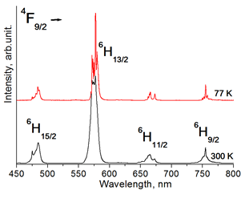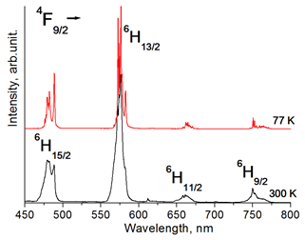
Figure 2. Luminescence spectra of [DyL₃TPPO] (left panel) and [DyL₃phen] (right panel) at 300 and 77 K.

The f-f emission of Dy (III) ion is sensitized efficiently by the ligands in both complexes. Upon excitation of the complexes at the maxima of the excitation bands, the characteristic f-f luminescence of Dy^{III} ion is observed (Figure 2). The band of hypersensitive transition ⁴F_{9/2}→⁶H_{13/2}, which corresponds to yellow emission, dominates in the spectra of both complexes. The emission quantum yield equals 8% and 1% for [DyL₃TPPO] and [DyL₃phen], respectively. The intensity of emission for the [DyL₃phen] is temperature dependent, being higher at 77K, that can be explained by back energy transfer from dysprosium to ligand due to not high enough energy of the phen ligand triplet level. The blue-yellow intensity ratio equals 0.2 for [DyL₃TPPO] and 0.5 for [DyL₃phen], corresponding to yellow light.
The compound [DyL₃phen] exhibits the properties of a single-ion molecular magnet induced by a field (500 Oe). The Arrhenius equation was used to determine the relaxation parameters U_{eff} = 21.2 cm⁻¹ and τ₀ = 2.01x10⁻⁷, which are within the limits for molecular magnets.
Thus, two luminescent Dy(III) complexes were successfully obtained. The compound [DyL₃phen] was found to be bifunctional, exhibiting also the behavior of single molecular magnet. While, [DyL₃TPPO] exhibits a fairly high luminescence quantum yield.

Acknowledgements. This project has received funding through the EURIZON project, which is funded by the European Union under grant agreement № 871072.

References
[1] Priya J., Gondia N.K., Kunti A.K. and Sharma S.K., Pure white light emitting tetrakis β-dikeonate dysprosium complexes for OLED applications. ECS J. Solid State Sci. Technol., 2016, 5, R166-R171.
[2] McAdams S. G., Ariciu A.-M., Kostopoulos A. K., Walsh J. P. S., Tuna F. Molecular single-ion magnets based on lanthanides and actinides: Design considerations and new advances in the context of quantum technologies. Coord. Chem. Rev. 2017, 346, 216 −239.

