PROCESSES OF ADSORPTION OF DYES ON THE SURFACE OF POTASSIUM TITANATE

Omelchuk Y.O.¹, Kucheruk S.V.,²Denysiuk R.O.³, Kaminskyi O.M. ⁴
Zhytomyr Ivan Franko State University,
10008, Zhytomyr, Velyka Berdychivska str., 40; juliaom04@gmail.com

Processes of adsorption of dyes on the surface of potassium titanate
The treatment of aqueous solutions from dyes is an important task for modern ecology and chemical technology. Dyes widely used in the textile, food and pharmaceutical industries are often toxic and biodegradable, making them difficult to remove from wastewater. Among the various treatment methods, adsorption processes on solid surfaces are considered to be an effective and cost-efficient way to remove dyes from solutions. In this context, the study of new adsorbents, in particular potassium titanate, is relevant[1].
In this work, the adsorption properties of potassium titanate synthesized by the alkaline leaching of ilmenite were investigated. The cationic dye methylene blue was chosen as a model pollutant. To compare the efficiency of the process, unmodified titanium dioxide (TiO₂) was also used.
Aqueous solutions of the dye were prepared at different concentrations, and its residual concentration after adsorption was determined spectrophotometrically using a UV-1200 spectrophotometer. It was found that the degree of methylene blue extraction by potassium titanate reaches 26.3 % within the first 5 minutes of contact, which is higher than in the case of titanium dioxide (20.5 %). The maximum recovery for methylene blue was 44.2 % after 10 minutes of contact (Fig. 1) [2].

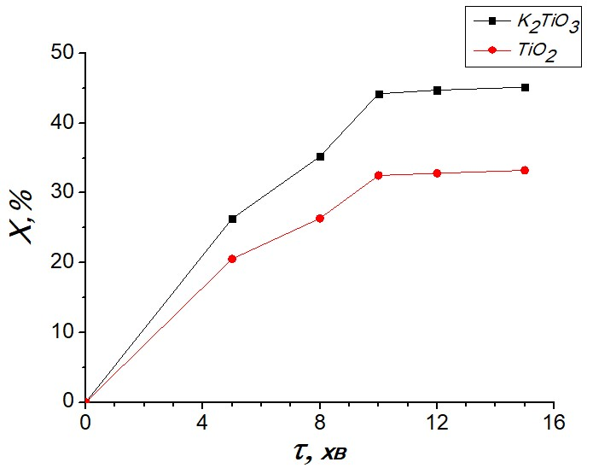

Fig. 1 Dependence of the degree of methylene blue extraction from aqueous solutions by the surface of potassium titanate on the contact time

The time dependence of the adsorption process was analyzed by pseudo-first and pseudo-second order kinetic models. It was found that the adsorption of methylene blue is better described by the pseudo-second-order model, as evidenced by the high correlation coefficient (R² = 0.959 for potassium titanate) (Fig. 2) [3].
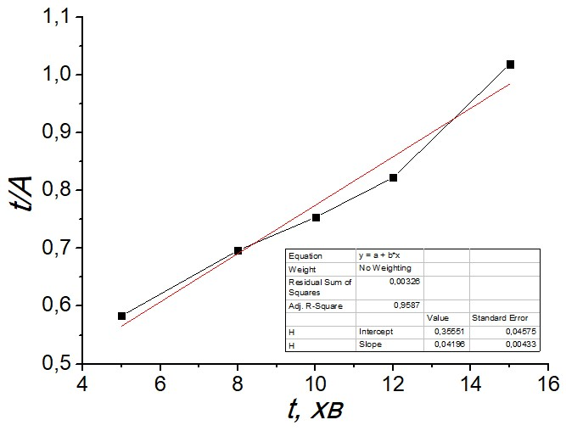
Fig. 2 Kinetic dependence of methylene blue adsorption by potassium titanate surface according to the pseudo-second-order model

Accordingly, the adsorption process is controlled by chemical interactions at the adsorbate-adsorbent interface, although physical adsorption dominates according to the calculated adsorption energy values. The initial rate of adsorption of methylene blue on potassium titanate was also slightly higher (2.9 mg/g-min) compared to titanium dioxide (2.5 mg/g-min).
The obtained results demonstrate that potassium titanate is a promising material for the removal of cationic dyes from aqueous solutions due to its higher adsorption efficiency, faster equilibrium and the ability to work at low adsorbent doses[4].
Thus, the processes of dye adsorption by the surface of potassium titanate are based on the mechanism of physical adsorption with elements of electrostatic interaction. This makes potassium titanate a promising material for wastewater treatment from contamination with organic dyes.

[1] Foo, K.Y., Hameed, B.H. Insights into the modeling of adsorption isotherm systems. Chemical Engineering Journal, 2010, 156 (1), 2–10. https://doi.org/10.1016/j.cej.2009.09.013
[2] Wang, S., Zhu, Z.H. Effects of acidic treatment on the surface properties of TiO₂ and its adsorption performance for dyes. Journal of Hazardous Materials, 2007, 136 (3), 469–477. https://doi.org/10.1016/j.jhazmat.2006.11.107
[3] Ho, Y.S., McKay, G. Pseudo-second order model for sorption processes. Process Biochemistry, 1999, 34 (5), 451–465. https://doi.org/10.1016/S0032-9592(98)00112-5
[4] Giles, C.H., MacEwan, T.H., Nakhwa, S.N., Smith, D. Studies in adsorption. Part XI. A system of classification of solution adsorption isotherms. Journal of the Chemical Society (Resumed), 1960, 3973–3993. https://doi.org/10.1039/JR9600003973

