CATION DEPENDENT LUMINESCENCE IN TETRAKIS-COMPLEXES OF RARE EARTH ELEMENTS WITH DYPHENYL-N-TRICLORACETYLAMIDOPHOSPHATE

Kariaka N.S.¹, Borysenko Y.V. ¹, Trush V.O.¹, Dyakonenko V.V.², Shishkina S.V.², Smola S.S.³, Amirkhanov V.M.¹
¹ Taras Shevchenko National University of Kyiv, 01601, Kyiv, Volodymyrska str., 64/13; Nataliia.Kariaka@knu.ua
² SSI ‘‘Institute for Single Crystals’’, National Academy of Sciences of Ukraine, 61001, Kharkiv, Nauky ave., 60; sveta@xray.isc.kharkov.com
³ A. V. Bogatsky Physico-Chemical Institute of the National Academy of Sciences of Ukraine, 65080, Odesa, Lustdorfska doroga 86 sssmola@gmail.com

Coordination compounds of lanthanides are objects of intensive research due to their specific spectral and magnetic properties, which are of interest for modern technologies [1, 2]. Organic ligands in the coordination compounds of lanthanides are used to enhance or modulate properties of Ln^{III} ions as well as to provide additional useful properties of compounds such as solubility, conductivity, biological activity, etc. An additional significant effect on luminescent and magnetic properties of lanthanides may result from outer-spherical ions and intermolecular interactions in the crystal lattice of complex. The later may influence on the geometry and electronic properties of the ligand as well as the geometry of the coordination polyhedron of the lanthanide and the "rigidity" of the complex. Therefore, the research aimed investigation of influence of the second coordination sphere of lanthanide ions properties and aiming deeper understanding of the mechanisms of their influence is relevant.
Herein, we report the synthesis and investigations of tetrakis-complexes of Y(III), Eu(III), Gd(III), and Tb(III) ions with carbacylamidophosphate type ligand diphenyl-N-tricloracetylamidophosphate (HL = [C₆H₅CONHPO(OPh)₂]) of general formula NMe₄[LnL₄] and NEt₄[LnL₄]. The obtained complexes were characterized by means elemental and X-ray analyses, ¹H NMR, IR, diffuse reflectance, and luminescence spectroscopy.
The complex NMe₄[EuL₄] crystalizes in monoclinic crystal system, P2₁/n space group. The complex NEt₄[TbL₄]·(i-PrOH) crystalizes as a solvate in monoclinic crystal system, C2/c space group. In both complexes the diphenyl-N-tricloracetylamidophosphate is coordinated to the Ln(III) ion in deprotonated form in bidentate chelating manner, leading to coordination number of the central atom equal 8. Coordination polyhedra of Eu (III) and Tb(III) ions in NMe₄[EuL₄] and NEt₄[TbL₄]·(i-PrOH) were interpreted as triangular dodecahedron (D_{2d}) and square antiprism (D_{4d}), respectively. The chelating metal cycles OCNPOLn have different deviations from planarity. For NMe₄[EuL₄] the two metal cycles are almost planar and the maximal atoms‘ deviations from the mean square plane created trough the atoms OCNPOLn are in range 0.0361 - 0.2343 Å. For NEt₄[TbL₄]·(i-PrOH) it is in range 0.0609 - 0.2637 Å and only one metal cycle is close to planar.
A similar feature of the excitation spectra of the obtained complexes of Eu(III) and Tb(III) is the presence of a broad band in the region of 280-325 nm (Figure 1, left panel). For the complex NEt₄[TbL₄] this band is slightly blue-shifted compared to the other compounds under investigation. More differences, such as different bands splitting, bands’ positions and their intensity ratios, are observed in the emission spectra (Figure 1, right panel), which is result of cations influence. The luminescence decay time for the complexes NMe₄[LnL₄] is higher compared to the NEt₄[LnL₄], being equal 2.53 ms for NMe₄[EuL₄], 1.73 ms for NEt₄[EuL₄], 2.36 ms for NMe₄[TbL₄], and 1.77 ms for NEt₄[TbL₄]. Analysis of the phosphorescence spectra of the Gd(III) complexes has shown that the energy of the ligands‘ lowest triplet state in the complexes NMe₄[LnL₄] is slightly lower than in the complexes NEt₄[LnL₄], being equal 22470 and 22830 cm⁻¹, respectively.
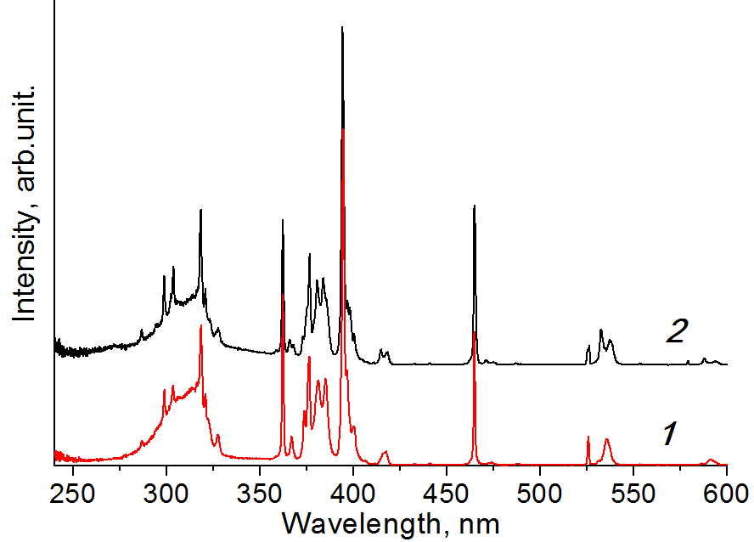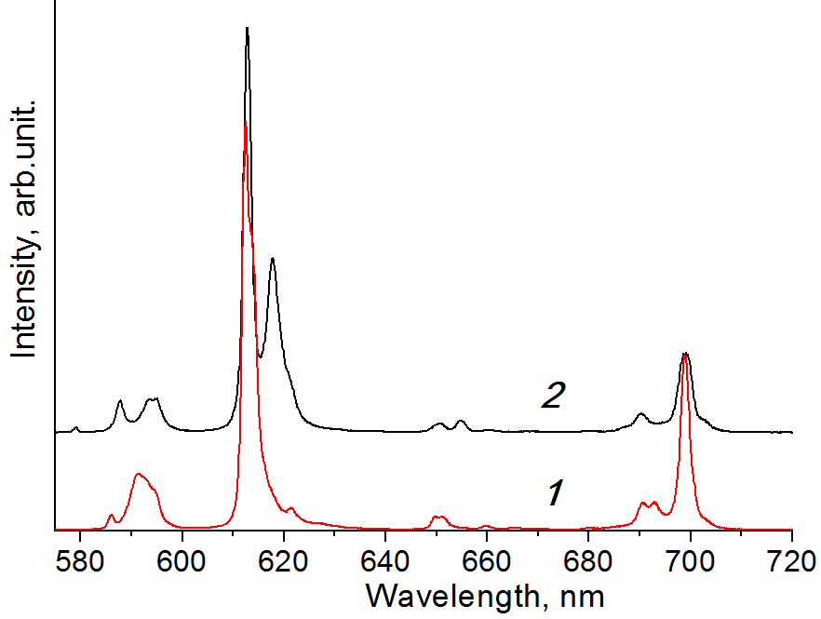
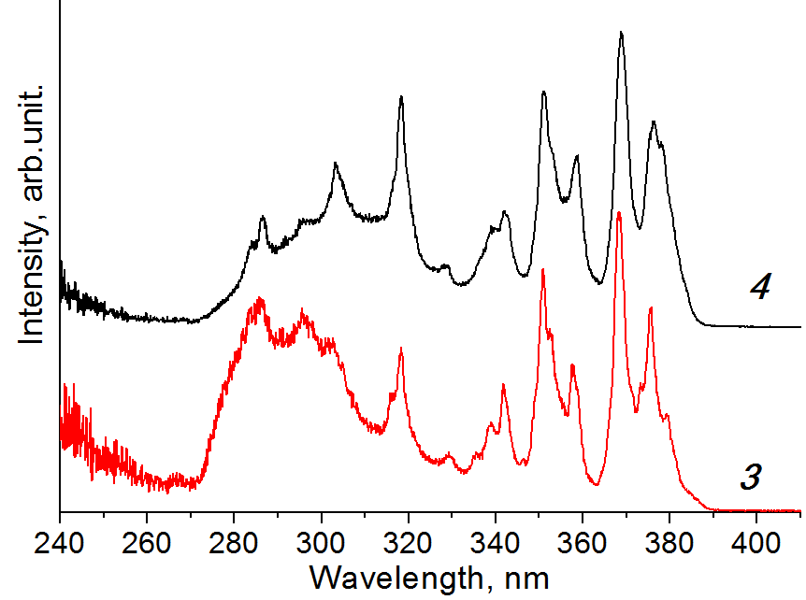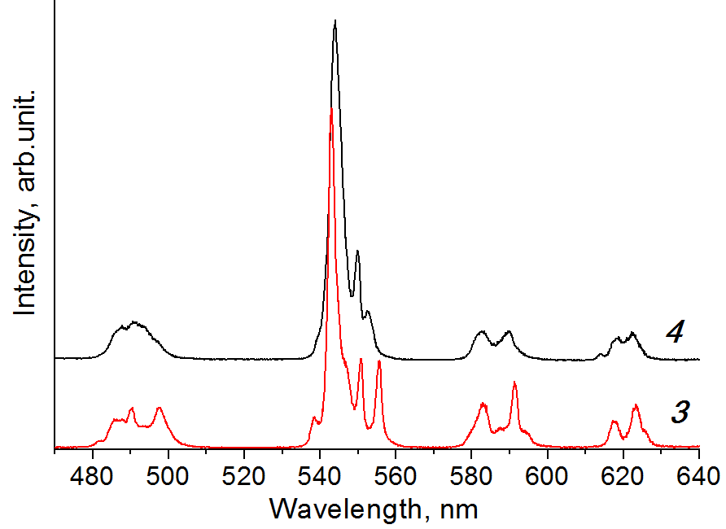
Figure 1. Normalized excitation (left panel) and emission (right panel) spectra of NMe₄[EuL₄] (1), NEt₄[EuL₄] (2), NMe₄[TbL₄] (3), and NEt₄[TbL₄] (4) at 298 K.

The current research contributes to the studies devoted to the influence of the cations on the properties of carbacylamidophosphate based tetrakis-complexes. The gained knowledge will allow designing and improving the photophysical characteristics of light converters based on lanthanide complexes.

References
[1] Bünzli, J.-C. G. Rising Stars in Science and Technology: Luminescent Lanthanide Materials. Eur. J. Inorg. Chem. 2017, 44, 5058-5063.
[2] Jia, J. H., Li, Q. W., Chen, Y. C., Liu, J. L., & Tong, M. L. Luminescent single-moleculemagnets based on lanthanides: Design strategies, recent advances and magneto-luminescent studies. Coord. Chem. Rev., 2019, 378, 365-381.

