SYNTHESIS AND ANTI-CANCER ACTIVITY OF SPIROCYCLIC β-KETO-γ-SULTONES

Poliudov A.O.¹, Sorokin M.D.¹, Virych P.A.², Dobrydnev A.V.²
¹ National Technical University of Ukraine “Igor Sikorsky Kyiv Polytechnic Institute”,
03056, Kyiv, Prospect Beresteiskyi, 37
² Taras Shevchenko National University of Kyiv
01601, Kyiv, Volodymyrska Street, 64/13
antonpoliudov@gmail.com

Small molecules are essential starting materials in early drug discovery and drug development projects. While designing the compounds with defined therapeutic properties they can be chemically modified to improve the potency, selectivity, pharmacokinetic properties, and safety profile. Sultones, akin to lactones, are the cyclic esters of hydroxy sulfonic acids hold significance as heterocyclic building blocks. This study is devoted to the synthesis of spirocyclic β-keto-γ-sultones and uncovering their biological activity.
The cytotoxicity of the studied sultones was determined against triple-negative breast cancer cells MDA-MB-231 and non-malignant cells MAEC. All the studied compounds were cytotoxic to MDA-MB-231 with maximum effects within 50% at 0.5 mM. Incubation of cancer cells with compounds 1d and 1a for 24 hours increases the difference between the control to 70-80% (Figure 1a). Cytotoxicity of the test compounds against non-malignant cells MAEC was not detected (Figure 1b). The maximum effect was not more than 20% at 0.5 mM that indicates the selectivity.
Figure 1. Cytotoxicity of compounds against triple-negative breast cancer cell line MDA-MB-231 (a) and non-malignant cells MAEC (b) (M ± SD).

Several proteins have been implicated in the aggressiveness and metastatic potential of the MDA-MB-231 cell line, including but not limited to epidermal growth factor receptor (EGFR, PDB ID: 3UG2), vascular endothelial growth factor (VEGF, PDB ID: 4ASD), estrogen receptor alpha (Erα, PDB ID: 1X7R), B-cell lymphoma 2 (BCL-2, PDB ID: 4AQ3), human cytochrome P450 aromatase (PDB ID: 4GL7), Janus kinase 2 (JAK-2, PDB ID: 3KRR), and cyclin-dependent kinase 1 (CDK-1, PDB ID: 4YC6). These proteins play crucial roles in mediating cellular processes associated with tumor progression, invasion, and metastasis; hence they were selected as targets for further docking study in AutoDock v.4.2.6 at the following parameters: 100 solutions with a population size of 500 and 2’500’000 evaluations, a maximum generational number of 27’000.
As it can be seen in Figure 2, the docked compounds possess the greatest binding affinities to estrogen receptor alpha target protein. The calculated values of inhibitory concentrations of the docked compounds with the target proteins suggest that the docked compounds can be considered potent inhibitors for the selected target proteins. Moreover, compounds 1a, 1d, a well as their enol forms 1’a and 1’d amid the most potent cytotoxic activity exhibited the highest binding affinity to estrogen receptor alpha with the minimal value of binding energy of ‒8.61 kcal/mol and inhibitory concentration of 492 nM.
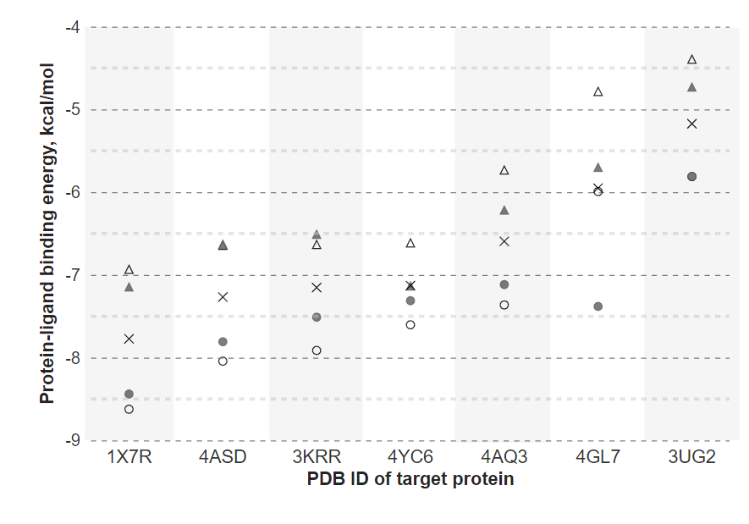
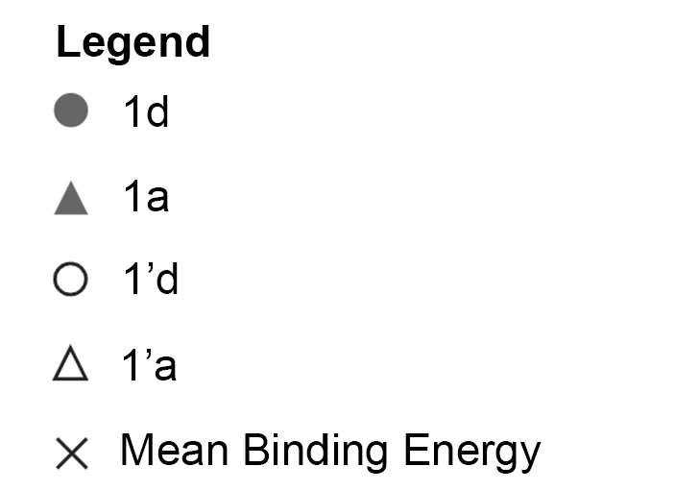

Figure 1. The lowest and average binding energies of docked compounds 1a, 1d, 1’a, and 1’d to the target proteins.

Compound 1d formed conventional hydrogen bonds with Ala 350 and Arg 394 residues (Fig. 1b). Other non-bonded interactions such as following: alkyl interactions involved with Leu 387, Leu 391, and Met 388 residues; van der Waal’s interactions involved Leu 346, Leu 349, Glu 353, and Leu 384 residues; carbon-hydrogen bond involved Phe 404 residue. These interactions were observed as depicted in Fig. 1 B.
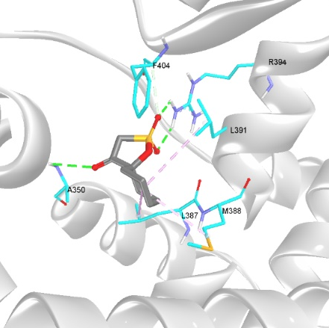 | 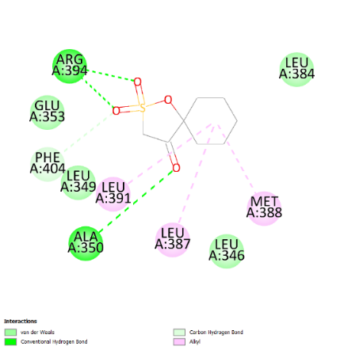
a | b
Figure 3. 3D visualization of interactions between estrogen receptor alpha (PDB ID: 1X7R) and 1d (a); 2D diagram of intermolecular interactions (b).

