IN SILICO ADMET PREDICTION OF THE PROPERTIES

OF NOVEL THIENOPYRIMIDINE DERIVATIVES

Mitina S.D., Varenichenko S.A., Farat O.K.
¹Ukrainian State University of Chemical Technology, 49005, Dnipro, pr Nauki 8, svetlanavarenichenko@gmail.com

The structural diversity of thienopyrimidines allows for the creation of a multitude of highly effective and low-toxic drugs with a wide spectrum of action. 4-Hydrazino-6,7-dihydro-5H-cyclopenta[4,5]thieno[2,3-d]pyrimidine (Figure 1) represents a unique system for the synthesis of various polyfunctional heterocycles through intramolecular nucleophilic addition reactions. [1].
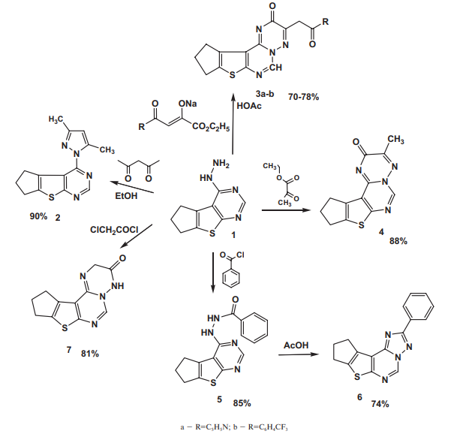
Figure 1

The ADMETlab 2.0 software resource was employed to assess the capabilities of ligands, compounds 1-8, in relation to biological targets. Additionally, the software was utilized to predict the profile of metabolism, excretion, toxicity, and the so-called ADMET properties of the ligand.
The compounds 1-7 align with Lipinski's rule. The compounds exhibit favorable indicators of intestinal absorption, clearance, and half-life. The predicted toxicity, mutagenicity, and carcinogenicity of the synthesized compounds are lower than those of the comparison drugs.
The presented derivatives of thienopyrimidines (Figure 1) are promising compounds for further pharmacological research due to the effective method of synthesis and pharmacokinetic indicators.

[1] Kolomieitsev D.O., Varenichenko S.A., Astakhina V.O., Markov V.I., Kovalenko S.I., Kharchenko O.V. The reactions of heterocyclization based on the 4-hydrazino-6,7-dihydro-5H-cyclopenta[4,5]thieno[2,3-d]pyrimidine. Voprosy khimii i khimicheskoi tekhnologii, 2016, 4 (108), 8-13.

