Identification of Microplastics (inc. tire rubber) Particles in Environmental Monitoring. Pyrolysis GC-MS Method Development

Задорожнюк Дарія¹, Jan H. Christensen², Peter H. Christensen²
¹ Київський національний університет імені Тараса Шевченка
01601, м. Київ, вул. Володимирська, 64/13;dariazadorozhniuk@gmail.com
² Section for Environmental Chemistry and Physics, University of Copenhagen
jch@plen.ku.dk

Microplastic (MP) contamination of the environment is an issue of rising concern due to their ability to readily incorporate into the biosphere, and absorb and interact with organic pollutants. A major source of microplastic contamination in urban areas is road and road run-off wastewater, which contains anthropogenic Tire and Road Wear Particles [1].
TRWPs have been detected not only in road dust, but also in soil, wastewaters, rivers, and lakes [2]. The quantification of the tire particles still remains a challenge because of their complexity, variety in size, and a number of additives added onto the polymer particles. Pyrolysis analysis can help with this issue, by using a “multi-step” temperature approach that allows the investigation of the organic additives and the polymeric matrix separately and successively [3].
Double-shot Pyr-GC/MS allows the performance of two consecutive analyses of a single sample under different pyrolysis temperatures. The first shot is used to thermally desorb the organic compounds at the surface of the sample or the additives included in the polymers using a specified heating program. It provides information on additives, regardless of the polymer, through rapid analysis of additives, in theory, without degrading the polymeric matrix. The second shot thermally degrades the polymer matrix at higher temperatures (>300°C) and gives data on the polymer fingerprint.
In my thesis, I aimed to develop and optimize a method for tire rubber microplastic detection from the road and road water run-off, as well as perform the novel analysis of plastic additives and organic toxins, adsorbed onto MPs in the environment or during the tire production, by double-shot pyrolysis-GC-MS. One of the first experiments included the optimization of the thermal desorption time for the 1st shot. The example of the obtained pyrogram is given below.

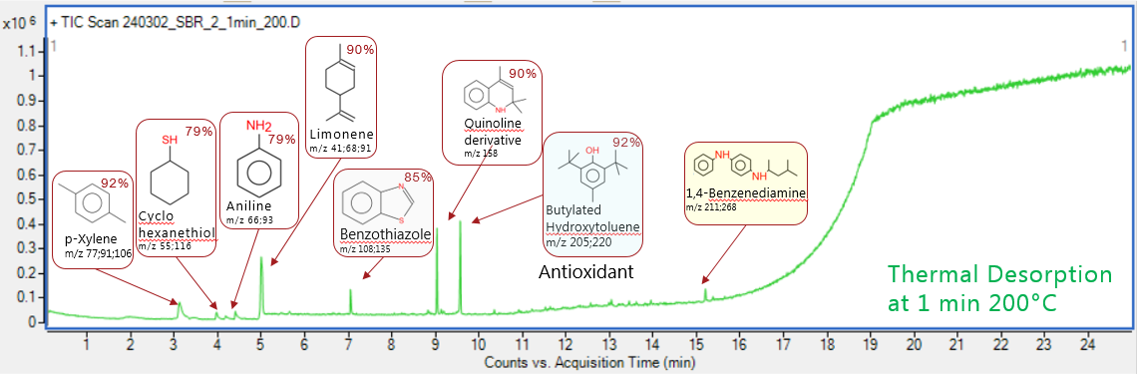

Figure 1. The pyrogram of SBR tire rubber with thermal desorption performed at 200°C for 1 minute combined with subsequent pyrolysis. The identified compounds by NIST library software for the GC/MS method given with the match factor percentage

A number of the leaching toxins were identified by the retention time and the mass spectra fingerprint of the compounds. Three target compounds: D-Limonene, Benzothiazole and 6-PPD were further confirmed with the internal standards, and will be quantified by the standard addition experiment. The results will be presented on the conference.

[1] Rauert, C., Rødland, E. S., Okoffo, E. D., Reid, M. J., Meland, S., & Thomas, K. V. (2021). Challenges with quantifying tire road wear particles: recognizing the need for further refinement of the ISO technical specification. Environmental Science & Technology Letters, 8(3), 231-236.
[2] Goßmann, I., Halbach, M., & Scholz-Böttcher, B. M. (2021). Car and truck tire wear particles in complex environmental samples–a quantitative comparison with “traditional” microplastic polymer mass loads. Science of the total environment, 773, 145667.
[3] Fries, E., Dekiff, J. H., Willmeyer, J., Nuelle, M. T., Ebert, M., & Remy, D. (2013). Identification of polymer types and additives in marine microplastic particles using pyrolysis-GC/MS and scanning electron microscopy. Environmental science: processes & impacts, 15(10), 1949-1956.

