SYNTHESIS, STRUCTURES AND OPTICAL PROPERTIES OF LEAD HALIDE HYBRID SYSTEMS MODULATED BY IMIDAZO[1,5-a]PYRIDINE OR IMINES

Vasylieva S.M.¹, Buvaylo E.A.², Kokozay V.N. ², Vassilyeva O.Yu.²
¹ National Technical University of Ukraine “Igor Sikorsky Kyiv Polytechnic Institute”,
37 Prospect Peremohy, Kyiv 03056, Ukraine; e-mail: s.vasylieva@kpi.ua
² Taras Shevchenko National University of Kyiv, 64/13 Volodymyrska str., Kyiv 01601, Ukraine; e-mail: vassilyeva@univ.kiev.ua

The organic-inorganic lead halide hybrids comprising semiconducting perovskite components and organic modules have emerged as promising materials for optoelectronic applications. The modulation of the inorganic components as optical centres by diverse organic cationic templates is under intense investigations. New one-dimensional lead halide hybrid perovskites [L1]_{2n}[Pb₂Cl₆]_{n∞}·nH₂O (1) and [PbBr₂(L2)]_{n∞}·0.5nH₂O (2), as well as the dimeric complex [PbBr₂(L3)]₂ (3) were successfully prepared in water media. In 1, 2-(2-hydroxyethyl)-2H-imidazo
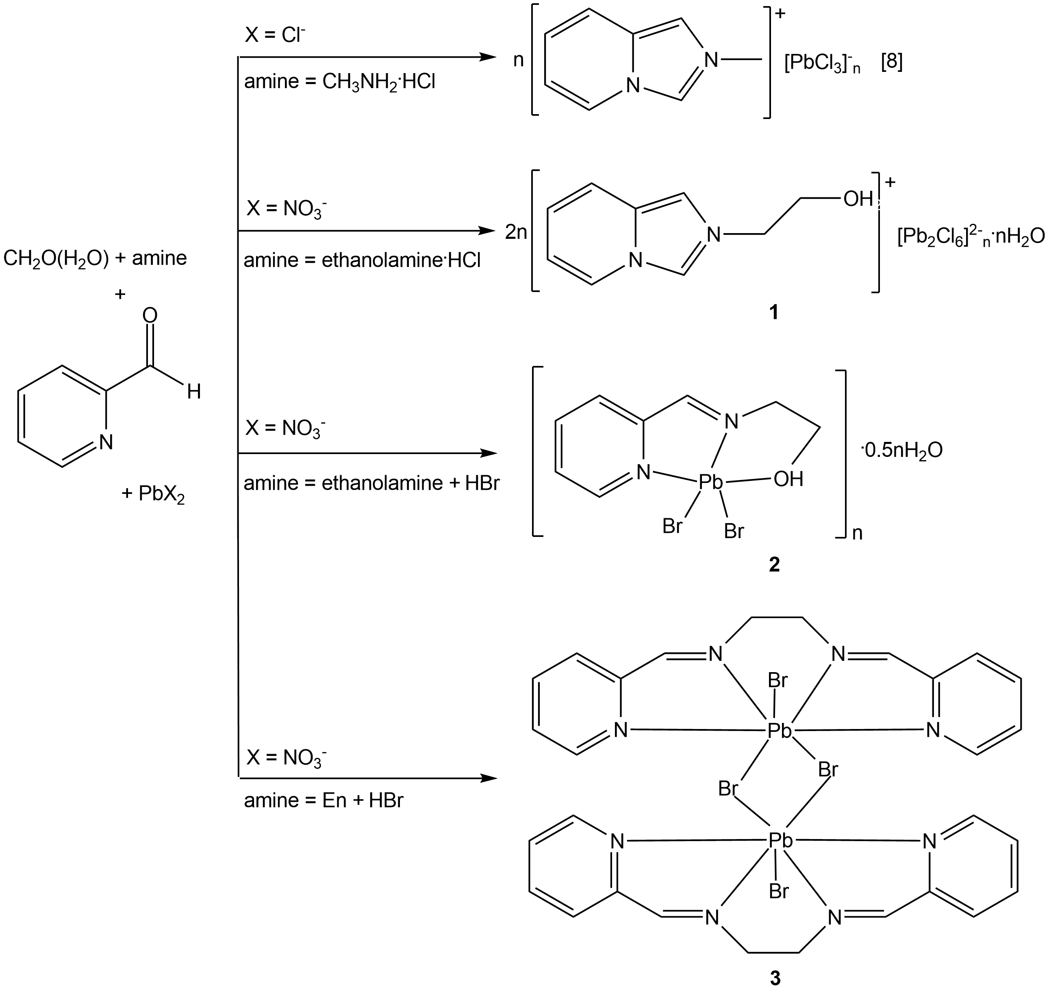 |  | [1,5-a]pyridinium cation [L1]⁺ resulted from the in situ oxidative cyclocondensation between formaldehyde, ethanolamine·HCl and 2-pyridinecarbaldehyde (2-PCA). In the case of 2 and 3, similar reaction procedures that used ethanolamine or ethylenediamine combined with HBr produced the polydentate Schiff base
1
2 | 3
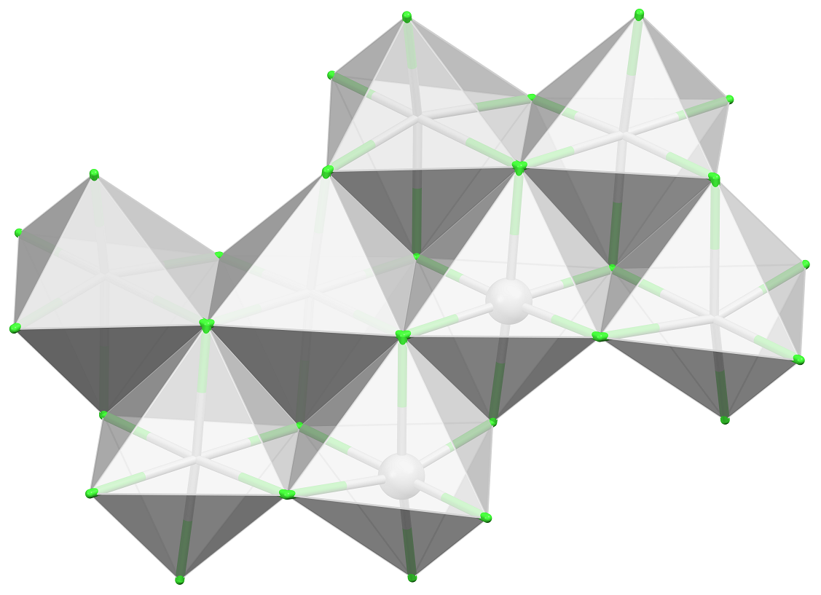
ligands L2 and L3 instead of expected imidazo[1,5-a]pyridinium cations presumably due to the insufficient acid strength.
The lead chloride hybrid 1 contains the previously unreported type of a [Pb₂Cl₆]∞ double chain constructed from 3-edge- and 5-edge-sharing PbCl₆ octahedra, and cations forming π-bonded stacks aligned along the inorganic wires.
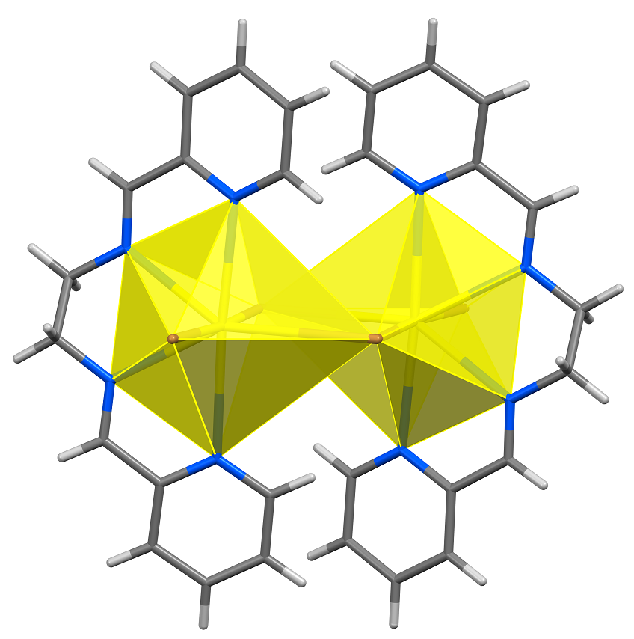
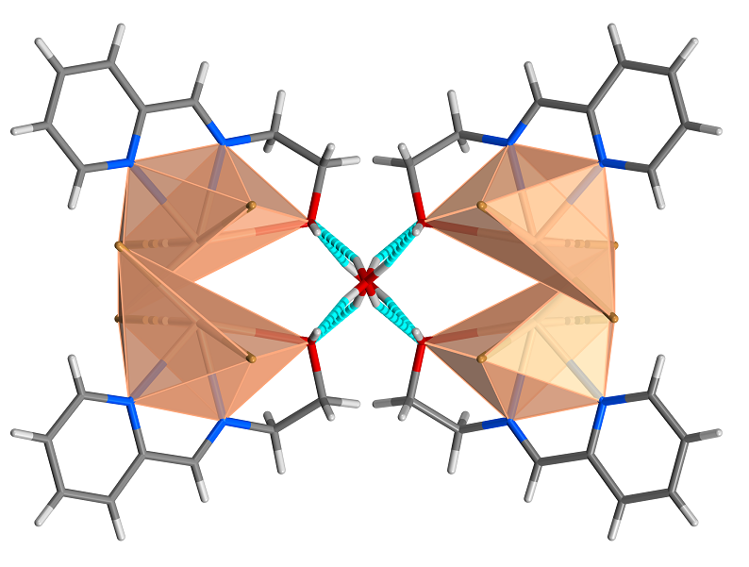
In 2, each lead atom is coordinated by one tridentate Schiff base, one terminal and two µ₂-Br ligands in a distorted octahedral environment. In the crystal, pairs of the double-side organically-decorated [PbBr₂(L2)]∞ chains built of corner-sharing PbBr₃N₂O octahedra arrange hydrophilic channels to host water molecules. In the 0D dimer 3, two irregular PbBr₃N₄ pentagonal pyramids are connected by edge sharing. The Pb···Pb’ separation in the dimer is 4.7239(5) Å. In the solid state, the identically stacked dimers of 3 form columns parallel to the ab plane with the Pb₂Br₄ moieties in the column being strictly coplanar.
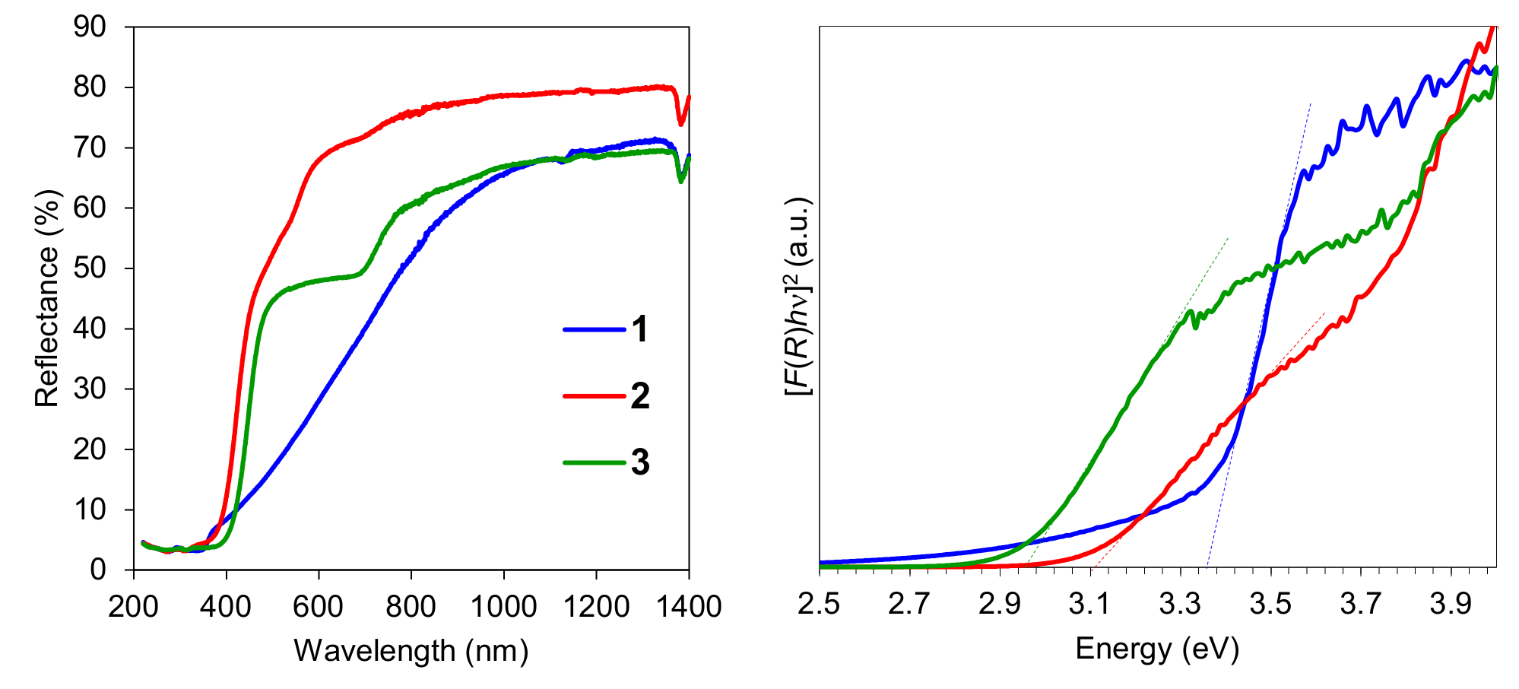
According to the analysis of the optical diffuse reflectance spectra by the Tauc plot based on the assumption of direct band gap, [F(R)hν]² versus hν (where F(R) is Kubelka–Munk function and hν is the photon energy in eV), the optical band gap values of 1, 2 and 3 were estimated to be 3.36, 3.13 and 2.96 eV, respectively. The band gaps successively going up from “corner-sharing” to “edge-sharing” and further “face-sharing” have been observed in the lead halide perovskite-derived organic-inorganic hybrids. The band gaps of 1 and 2 with different connectivity follow the general trend of edge-sharing perovskites exhibiting larger band gaps than corner-sharing structures.

