SPECIFICATIONS OF COBALT COATING BY BIPOLAR ELECTRONIC METHOD

Kuzevanova I.S. ¹, Zulfigarov A.O. ¹, Vlasenko N.E. ¹, Kovalenko I.V. ¹
¹ National technical university of Ukraine “Igor Sikorskyi Kyiv Polytechnic Institute”; 37, Beresteysky Avenue, Kyiv, Ukraine, 03056
kuzevanova2009@ukr.net

The speed of the electrochemical process of metal application is determined by the current density, which is a function of such properties as: composition of the electrolyte, temperature, circulation speed, electrode movement, and the other [1,2].
The study of the potential distribution, the influence of current density, and other components of the electrochemical process for monopolar (with current removal) and bipolar (without current removal) electrodes.

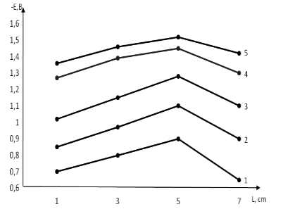

Fig. 1. The dependence of potential distribution on the length of the wire - monopolar, at current density, А/dm2: 1 – 50, 2 – 60, 3 – 70, 4 – 80, 5 – 90

Here, the potential distribution along the length of the monopolar electrode is clearly presented. It is clearly seen that when moving away from the contact point, a uniform distribution of the potential occurs, which is associated with an increase in the resistance of the electrode - wire. Heating and metal overgrowing of the contact point - direct current to the wire.

- Bayrachny B.I., Orekhov V.V. (1988). Spravochnik gal'vanika [The reference of the galvanic]. Kharkov: Prapor, p.180.
- Yurtov E.V., Matveeva A.G. (2013). Shablon dlya prigotovleniya pokrytiya iz nanostrukturirovannogo nikelya [Template for the production of nanostructured nickel coathing]. Chemistry technology, 14(1), pp. 24-29.

