Cu-CONTAINING HYBRIDS WITH LACUNARY STRANDBERG ANIONS: SYNTHESIS, CRYSTAL STRUCTURE AND MAGNETIC PROPERTIES

Buvailo H.I., Makhankova V.G., Kokozay V.N.
Taras Shevchenko National University of Kyiv, 64/13 Volodymyrska str., Kyiv 01601, Ukraine; e-mail: halyna.buvailo@gmail.com

Structural and compositional diversity of polyoxometalates (POMs) combined with versatile binding of complex cations to the inorganic oxide structure enables formation of novel organic-inorganic materials. The resulted hybrids have great potential toward applications in photo- and electrocatalysis. The ability of POM-based compounds to build SMM materials demonstrating slow magnetization relaxation may find applications in high-density information storage, spintronics and quantum processing.
The one-pot reactions of a copper source (zerovalent copper powder or Cu²⁺ salts) and bpy (bpy = 2,2’-bipyridine) in the presence of (NH₄)₂HPO₄ and (NH₄)₆Mo₇O₂₄·4H₂O in aqueous media yielded heterometallic phosphomolybdate hybrid compounds {[Cu(bpy)₂][Cu(bpy)(H₂O)] [P₂Mo₅O₂₃]}∙6H₂O (1), {[Cu(bpy)(H₂O)]₄[P₂Mo₃O₁₈]}∙8H₂O (2) and {[Cu(bpy)(H₂O)]₅ [P₂Mo₂O₁₅]}(NO₃)₂∙5H₂O (3). The structures exhibit a variety of POM building blocks including the common Strandberg anion [P₂Mo₅O₂₃]^{6–} as well as its unprecedent bi- and trilacunary derivatives [P₂Mo₃O₁₈]^{8–} and [P₂Mo₂O₁₅]^{8–}.
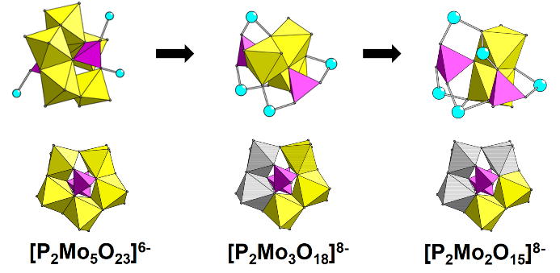

Figure 1. View of the copper coordination to POMs (up) and structures of POMs in 1–3 (bottom) with absent MoO₆ fragments in the lacunary Strandberg anions shown in grey.

The ex situ EPR study revealed the formation of different Cu^{II} complexes in the reaction mixture depending on the copper precursor. The obtained compounds have been found to possess selectivity towards the sorption of methylene blue in a mixture of organic dyes. DC magnetic measurements of 1−3 indicate rather strong antiferromagnetic metal-metal exchange interactions. Compound 1 exhibits field induced slow magnetic relaxation in AC magnetic measurements, which is a rarely observed phenomenon among Cu(II) complexes.
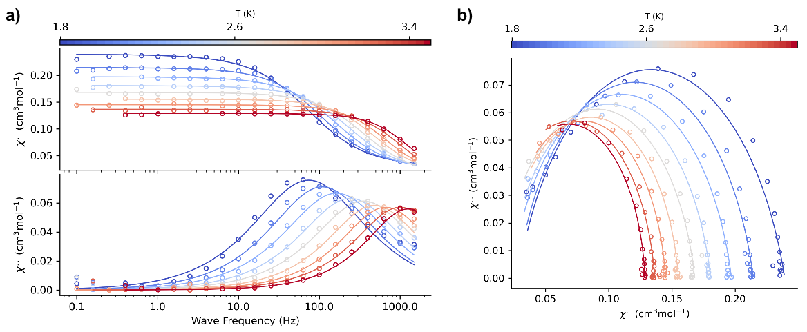
Figure 2. (a) Frequency dependence of the AC susceptibility components for 1 at B_{DC} = 0.1 T and fixed temperature (circles). Lines – fitted; (b) Argand diagram for 1 (fixed temperature); lines: calculated upon fitted parameters.

