ANALYTICAL METHOD OF PICROCROCIN ISOLATION
FROM SAFFRON

Mykhailenko O.O.¹, Ivanauskas L.², Georgiyants V.A.¹
¹ Department of Pharmaceutical Chemistry, National University of Pharmacy of Ministry of Health of Ukraine, 4, Valentynivska str., 61168, Kharkiv, Ukraine, e-mail Mykhailenko.farm@gmail.com
² Department of Analytical and Toxicological Chemistry, Lithuanian University of Health Sciences, A. Mickevičiaus g. 9, LT 44307 Kaunas, Lithuania; e-mail Liudas.Ivanauskas@lsmuni.lt

Natural products from medicinal plants, either as pure compounds or as standardized extracts, provide unlimited opportunities for new drug leads because of the unmatched availability of chemical diversity. Due to an increasing demand for chemical diversity in screening programs, seeking therapeutic drugs from natural products, interest particularly in edible plants has grown throughout the world. Saffron is a spice derived from the plant Crocus sativus. The bright-red stigma is harvested and dried for use as a condiment and color in food, and also as a medicinal product [1].
The bitter glucoside picrocrocin is responsible for the taste of saffron. Picrocrocin (chemical formula: C₁₆H₂₆O₇; systematic name: 4-(β-D-glucopyranosyloxy)-2,6,6-trimethylcyclohex-1-ene-1-carbaldehyde) is a combination of an aldehyde submolecule known as safranal (C₁₀H₁₄O; systematic name: 2,6,6-trimethylcyclohexa-1,3-diene-1-carbaldehyde) and carbohydrate. It has insecticidal, pesticidal and anticancer properties. Saffron contains between 2.7 and 12.9% picrocrocin [2]. Picrocrocin is a truncated version of the carotenoid zeaxanthin, which is produced by oxidative cleavage, and is a glycoside from the terpenes of the safranal aldehyde.

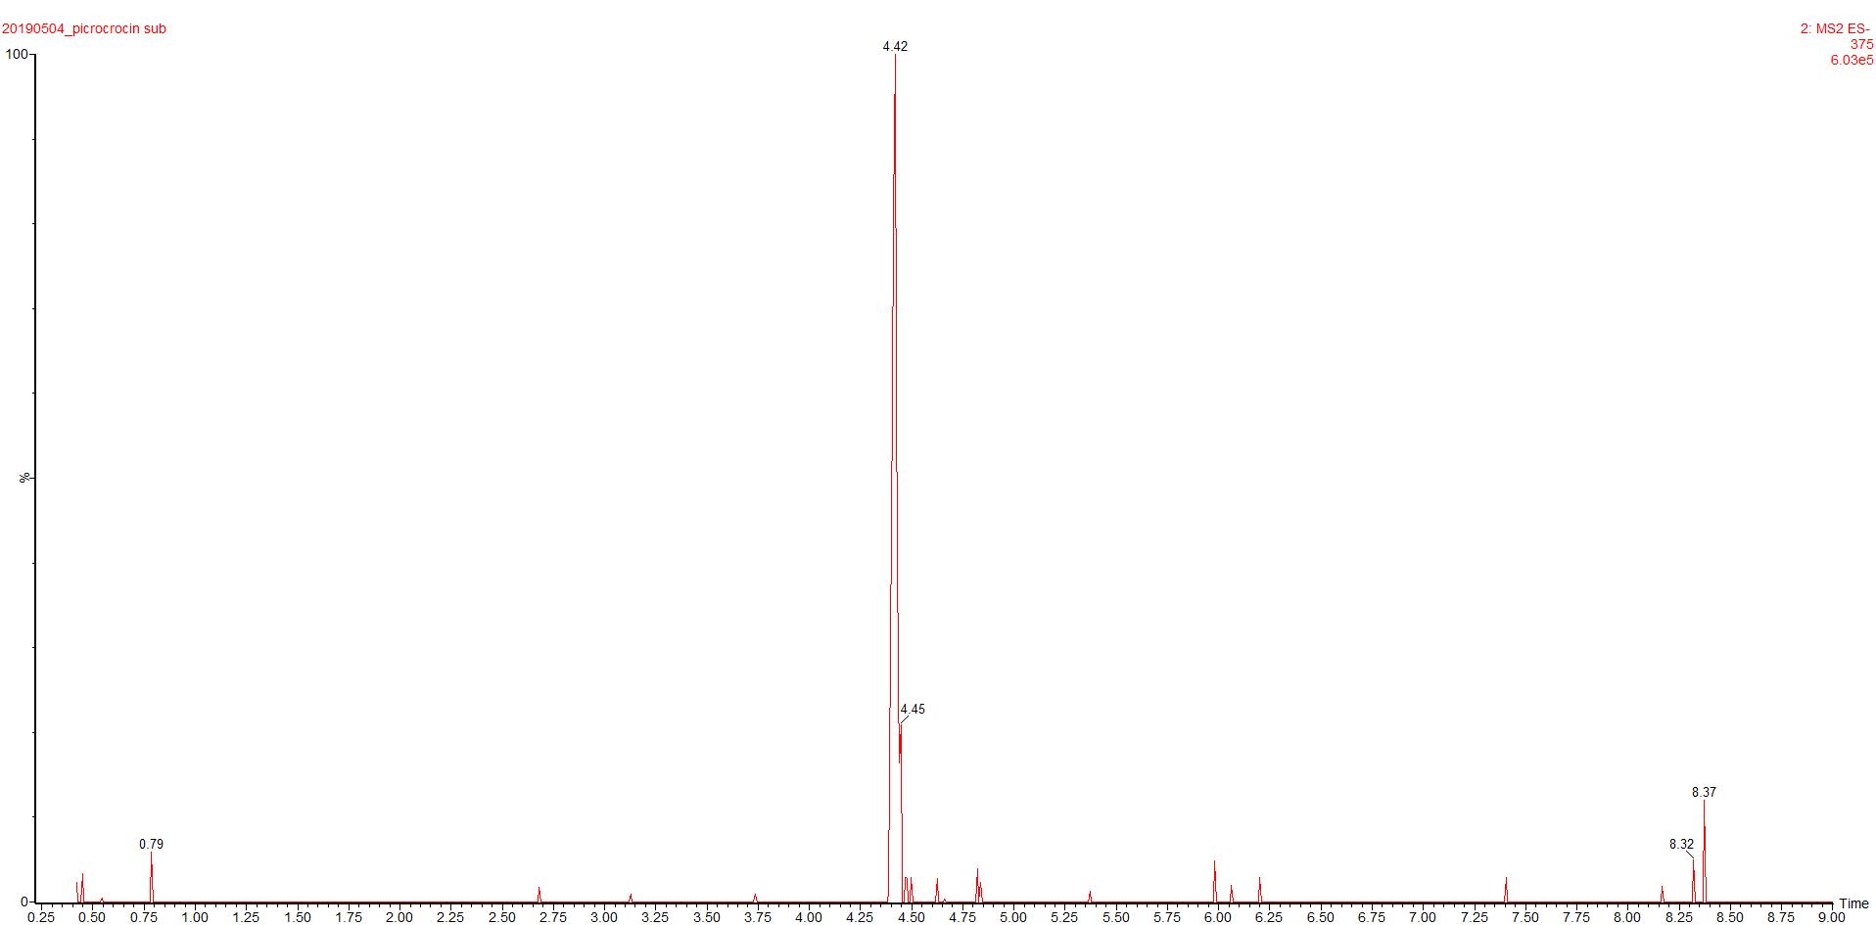

Figure 1. UPTLC-MS/MS chromatogram and structure of picrocrocin.

The results of our study demonstrates a simple method for picrocrocin isolation as one of the main secondary metabolites of the methanolic extract of Crocus sativus stigmas (saffron) using preparative chromatography. The analysis was performed using a Waters preparative HPLC Purification System with a Symmetry Prep C18 (300 × 19 mm × 7 µm) column for isolation, using the mobile phase composition of a mixture of 0.1% acetic acid (A) and acetonitrile (B) solvents. The purity of picrocrocin was studied using HPLC-DAD, UV-visible spectrophotometry and UHPLC-ESI-MS/MS (Fig. 1). The purity of picrocrocin was more than 97%.
Література
[1] Jarukas L., Mykhailenko O., et al. Investigation of organic acids in saffron stigmas (Crocus sativus L.) extract by derivatization method and determination by GC/MS. Molecules 2020, 25, 3427-3437
[2] Agnihotri V. K. Crocus sativus Linn: an informative review. Aperito J. of Adv. Plant Biol., 2015, 1 (1), 1-29.

