Application of LASSO logistic regression to classification problems in chemistry

Berdnyk Mykhailo¹, Ivanov Vladimir ¹
¹ V. N. Karazin Kharkiv National University
4 Svobody Sq., Kharkiv, 61022, Ukraine; e-mail: berdnikm@i.ua

In the era of data the amount of chemical information concerning different molecular properties including but not limited to: pK, basicity, boiling points, bioavailability, different toxicity characteristics etc. continuously grow. Today there are multiple open databases on the internet which are dedicated to collect the data and store it in the systematic way. To use this data and develop models to predict the properties of the molecules with the unknown parameters there are multiple methods and approaches proposed in the field of machine learning. The statistical model building in chemistry is known as QSPR (Quantitative Structure–Property Relationships).
While QSPR in applied sciences is mostly associated with models which can provide the actual values of discovered properties there are multiple tasks which do not require that. Instead the simple classification can be expected from the models to answer the questions like “is the compound acidic or basic?”,”is the reaction possible or not?” etc. While there are several classification approaches used to build classification models in biological chemistry, biology, drug development fields most of the currently used machine learning methods fail to provide researcher with the general information about structural features and/or chemical/physical properties which result –whether the molecule possessing or not the desired property. Thus the methods which can provide the straightforward answer to this question and also be able to work with huge amount of data by using simple desktop computers are required. In our work we propose the usage of LARS-LASSO (Least Angle Regression-Least Absolute Shrinkage and Selection Operator) logistic regression method to handle such tasks:
,
Where x_{i} – molecular descriptors, a_{i} – regression parameters. In our work we show that the method while being computationally undemanding can provide the equations in which various structural descriptors explicitly participate thus providing the researcher with the idea what classes of molecules are more suitable. The obtained models appeared to provide valuable alternative to existing popular classification methods such as random forests which in turn does not provide explicit information on what structural features define property (see fig. 1).
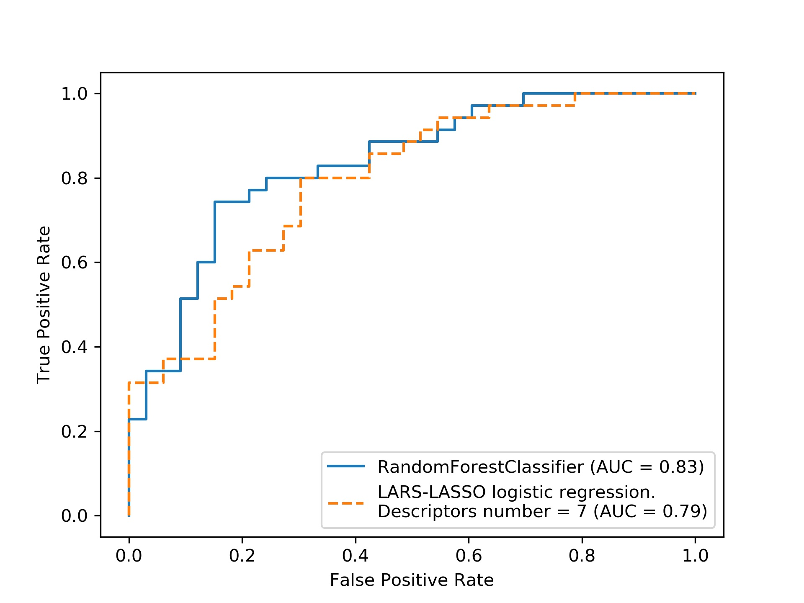
Fig.1 the Receiver operating characteristic (ROC) curve obtained for Li-cation basicity property test-set molecules classification.

