THE INTERACTIONS IN Cu−CuBr₂−3,5-DIMETHYL-1H-PYRAZOLE SYSTEM: SYNTHESIS AND CRYSTAL STRUCTURE OF MONO- BI- AND TRINUCLEAR COPPER (II) PYRAZOLATE COMPLEXES

Oleksandr. S. Vynohradov, Vadim. A. Pavlenko
Taras Shevchenko National University of Kyiv
01601, Kyiv, Volodymyrska str, 64/13; linke33967@gmail.com

By reaction of copper powder and copper (II) bromide with 3,5-dimethyl-1H-pyrazole, three different crystalline species were formed and recovered through fractional crystallization. In order, the trinuclear Cu₃(µ₃-OH)(HDMPz)₅(µ₂-4Br35DMPz)(µ₂-Br)₃Br·CHCl₃ (HDMPz = 3,5-dimethyl-1H-pyrazole, 4Br35DMPz = 4-bromo-3,5-dimethylpyrazole) (1), the binuclear Cu₂(HDMPz)₄(µ₂-4Br35DMPz)(µ₂-Br)Br₂·2CHCl₃ (2) and the mononuclear Cu(HDMPz)₃Br₂ (3) complexes were obtained. The structure of 1 is similar to the structure of 9-MC-3 trinuclear copper complexes where µ₂-Br atoms are located instead of bridging ligand molecules. Complex 3 is an atypical representative of the mononuclear copper (II) coordination compounds where the central atom is in the trigonal-bipyramidal geometry (τ₅Cu1 = 0.777). Crystal data for compounds 1, 2 and 3 are reported in table and the molecular structures of these complexes are shown in figure.

Table. Crystal data for complexes
 | 1 | 2 | 3
Chemical formula | C₃₀H₄₇Br₅Cu₃N₁₂O  ·CHCl₃ | C₂₅H₃₈Br₄Cu₂N₁₀ ·2CHCl₃ | C₁₅H₂₄Br₂CuN₆
M | 1301.33 | 1164.11 | 511.76
Crystal system, space group | Orthorhombic, Pnma | Monoclinic, C2/c | Triclinic, P
a, b, c (Å) | 19.9353 (8), 14.6342 (8), 16.4342 (7) | 18.4331 (13), 13.4024 (6), 18.2358 (9) | 9.1353 (6), 9.6978 (6), 12.7716 (5)
α, β, γ (°) |  | β = 94.231 (4) | 105.880 (4), 97.800 (5), 103.709 (5)
V (Å³) | 4794.5 (4) | 4492.8 (4) | 1032.64 (11)
Z | 4 | 4 | 2

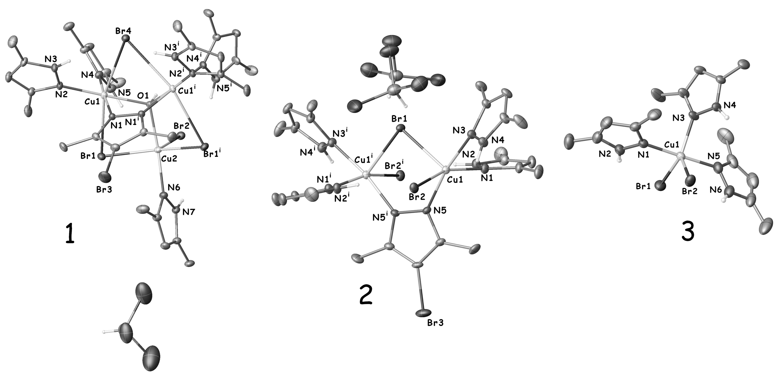
Figure. Molecular structures of complexes

