UNPRECEDENTED PHENYLPHOSPHINIDENE TRANSFER REACTIONS FROM CARBENE-PHOSPHINIDENE ADDUCTS

Krachko T., Slootweg J. C.
Van 't Hoff Institute for Molecular Sciences, University of Amsterdam
1090 GD Amsterdam, Science Park 904, PO Box 94157; e-mail: t.krachko@uva.nl

Phosphinidenes are convenient precursors for the synthesis of great variety of organophosphorus compounds.¹ Most of the reported phosphinidene sources, such as phosphanorbornadiene or (benzo)phosphepine complexes, characterize poor atom economy and use of transition metal complexes to stabilize the low coordinate phosphorus species.² Therefore, there is still the need for easily accessible phosphinidene transfer reagents, which allow an access to uncomplexed P-products.
Although carbene adducts of phenylphosphinidene (NHC=PPh)³ have been known for more than a decade and studied in detail computationally, there are no examples that describe the transfer of the phenylphosphinidene fragment from any of the carbene-phosphinidene adducts.
Herein, we present the reactivity of ^{Me}NHC=PPh (1) toward organic electrophiles that results in phenylphosphinedene transfer reactions. We also show that the reactions can be tuned by the employment of ZnCl₂ (Scheme 1). In addition, the reaction pathway of these phosphinidene transfer reactions is proposed based on DFT calculations as well as the determination of crystal structures of intermediates and products.

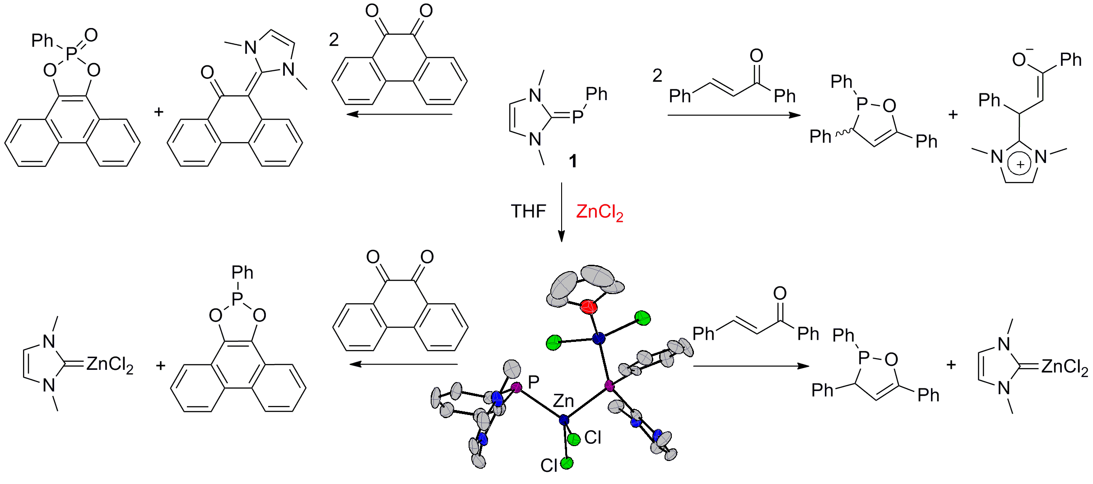

Scheme 1. Phosphinidene transfer reactions from ^{Me}NHC=PPh

Key words: phosphorus heterocycles, phosphinidene, carbenes, cycloadditions, density functional calculations

References:

1 C. Slootweg, K. Lammertsma, Science of Synthesis, Vol.42; 2009.
2 F. Mathey, N. Huy, A. Marinetti, Helv. Chim. Acta 2001, 84 (10), 2938.
3 A. Arduengo, J. C. Calabrese, A. H. Cowley, H. V. R. Dias, J. R. Goerlich, W. J. Marshall, B. Riegel, Inorg. Chem. 1997, 36 (10), 2151.

