Highly effective photodynamic inactivation of Escherichia Coli pathogens using gold nanorods/SiO2 core-shell nanostructures with embedded verteporfin

Turcheniuk V.^{1,2}, S. Szunerits.², Zaitcev V.¹
¹Taras Shevchenko National University of Kyiv, 60 Volodymyrska St., 01033 Kyiv, Ukraine
² Institut d'Electronique, de Micro ́electronique et de Nanotechnologie (IEMN), UMR CNRS8520, Universit ́e Lille1, Avenue Poincar ́e-BP 60069, 59652 Villeneuve d'Ascq, France.
E-mail: v.turcheniuk@gmail.com

Antimicrobials have become an essential tool for modern medicine. However, despite extensive efforts in research and enormous investment of resources, the development of new antimicrobial drugs cannot catch up with the development of antibiotic resistant pathogens.,

We describe in this work the development of silica-coated gold nanorods (Au NRs@SiO2) withembedded verteporfin (VP), a clinically approved photosensitizer, as efficient nanostructures for NIR PDT using either a continuous wave (CW) or a pulsed-mode laser, for the eardiaction of a virulent strain of E. coli associated with urinary tract infection (UTI).

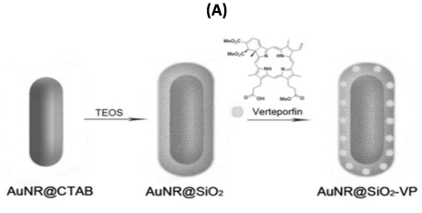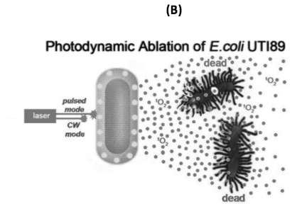
Figure 1. Illustration of the formation of Au NRs @SiO2-VP (A) and their use for the inactivation of E. coli UTI89 using PDT with a CW of pulsed-mode laser(B).

S. G. Bell, Neonatal. Netw, 2003, 22, 47.
N. K. Petty et al., Proc. Nat. Acad. Sci. USA 2014, 111, 5694-5699.
M.Khurana et al., Photochem. Photobiol., 2007, 83, 1441.
K. Turcheniuk et al., Mater. Chem. B, 2015, 3, 375-386.

